Pizza For You

**User’s Manual**

**Contents**

1. Overview

About Our Website

1. Getting Started

Registration and Log-in

Menu and Orders

Customer Accounts

Seller List

1. Setting Up Database

Installing for Windows

1. Setting Up Sqlite Browser in Windows

Installing for Windows

1. Creating database using Sqlite Browser
2. Connecting Website to Python and Flask Framework

**Overview**



## **Pizza For You**

Pizza For You’s delivered over 400 million pizzas last year. That’s just over one pizza for everyone in the United States. Our delivery people drive more than 10 million miles every week to bring you the best pizza we can make. We operate over 11,000 pizza places in more than 80 countries dedicated to providing great tasting pizza for carryout or delivered to your door. How did we become such a powerhouse of pizza delivery? Let’s look.

## **Pizza For You’s** History

From humble beginnings as a single pizza restaurant in 1960, Pizza For You today has become the recognized world leader in pizza delivery. We have been dedicated to making and delivering great pizza with high quality ingredients from the start. In addition, we are constantly updating and improving our pizza menu to satisfy the growing needs of our customers.

Beyond pioneering the concept of efficient delivery of made-to-order pizzas, we have been part of innovations that have made a significant impact on the entire food delivery industry:

* Pizza For You (Global) pioneered patented insulating pizza bags to keep pizzas oven-hot and crisp during normal delivery.
* Pizza For You (Global) created the sturdy, corrugated pizza box, which keeps moisture from weakening the box and cheese from sticking to the top.

**About Website**

Developer: Shunting Ligmayo

Contents : Kathleen Cahinde, Kyle Kurt Soriano, Jemimah Panteleon

Details: Tristan Jose Dizon ,Kimberly Rodriguez

Date Started: June 2021

Date Finished: July 2021

**Getting Started**

**Registration & Log in**

To be able to obtain an account to this website, you should create one first. To do it, follow the procedure;

1. First, you need to contact the administrator to register your account.

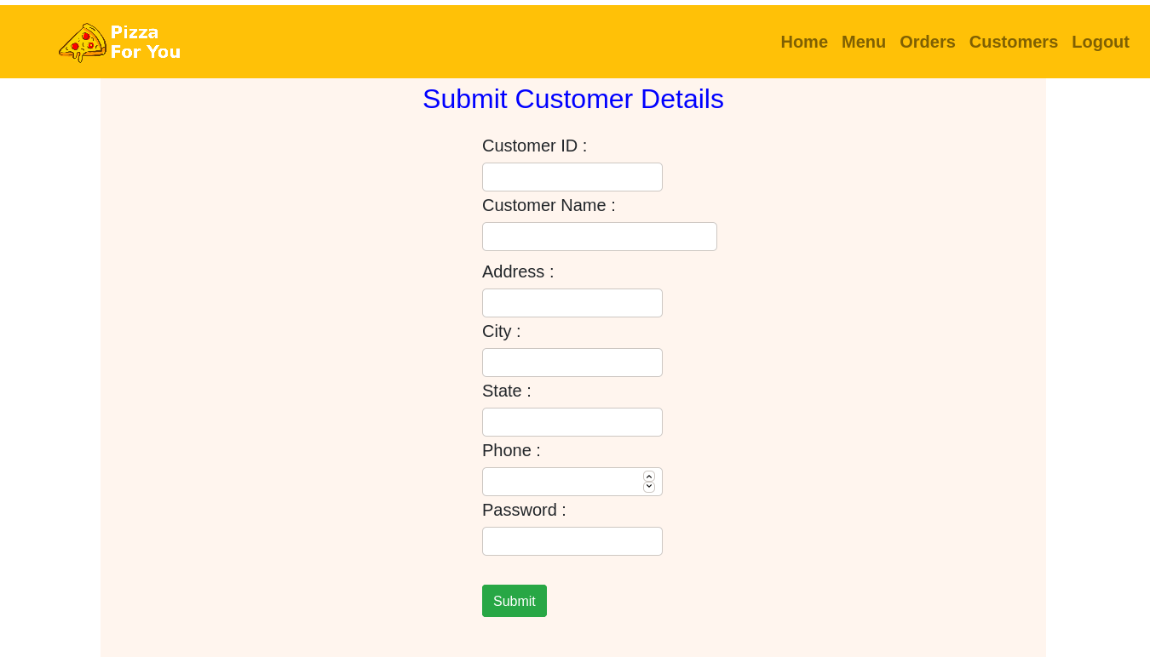

1. The administrator will send an email regarding to your account.
2. After clicking the Log In button, it will direct you to another webpage called Log In. In this webpage you should fill up the Customer ID and password that the administrator gave you.

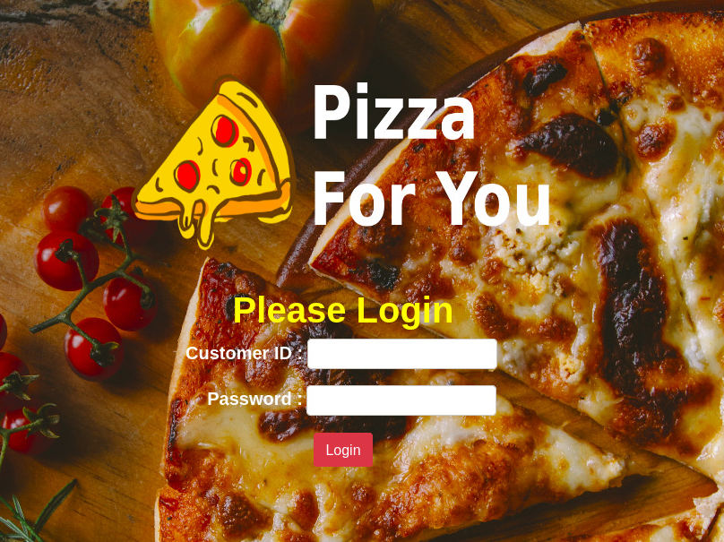

1. After providing needed informations, click the Log In button and it will direct you to the Home page.

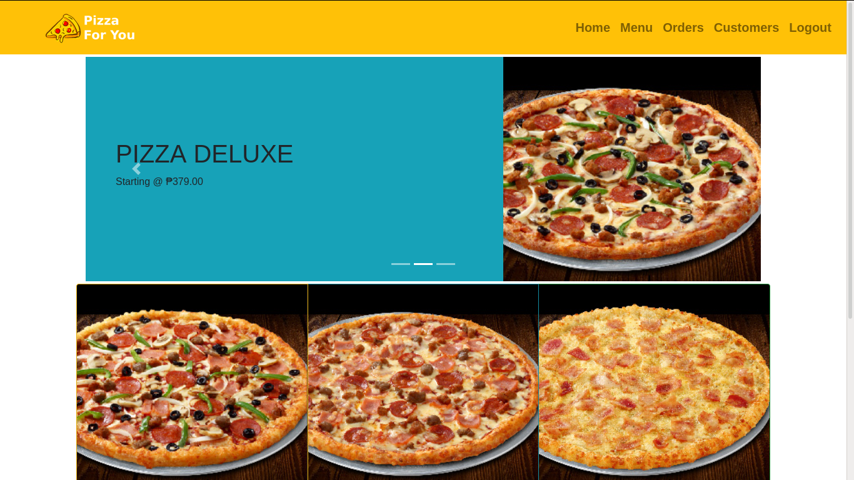

**Menu and Orders**

If you have chosen your desired pizza and wanted to order it, follow the procedures below;

1. Go to Menu.

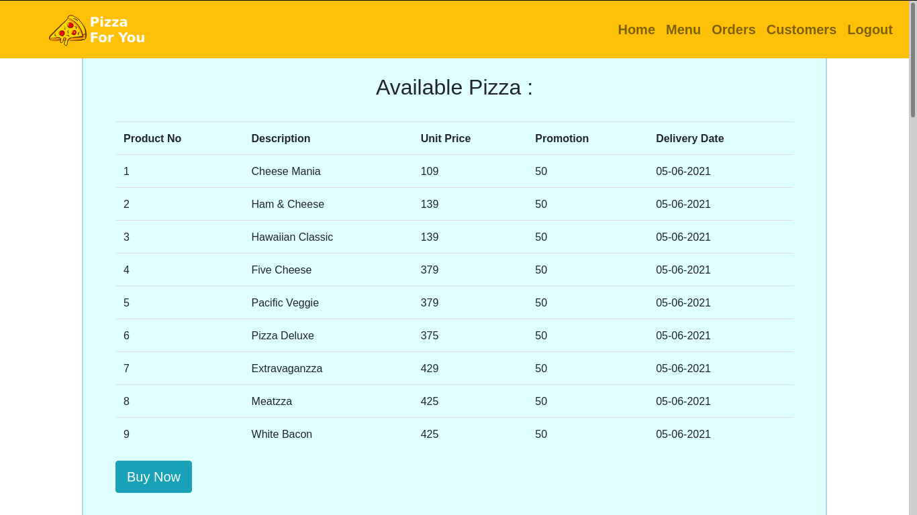

1. Click the Buy Now button.

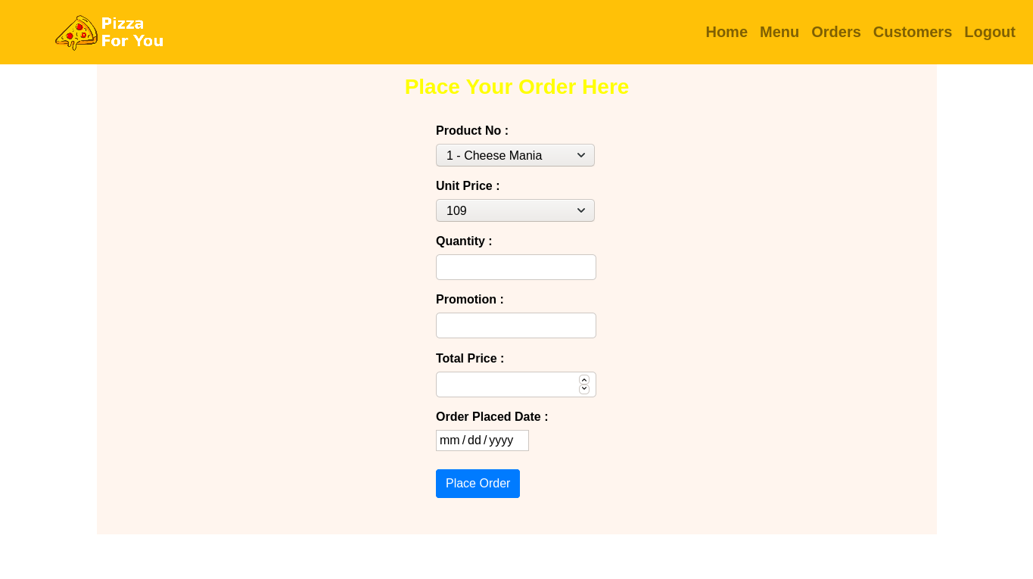

1. Choose flavor of your pizza.
2. Select the price range.
3. Put some quantity.
4. Choose you desired date for delivery.
5. Click the Place Order button to order the pizza.
6. Click the Order button on the navigation bar to view your orders.

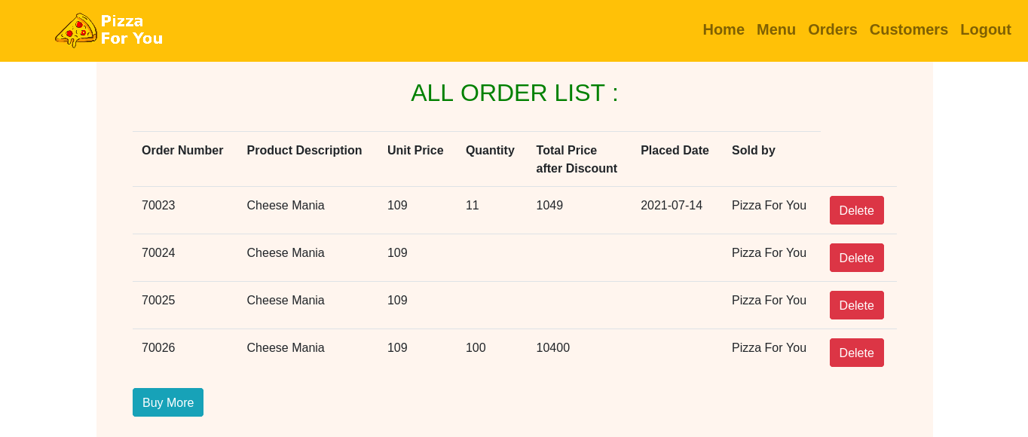

**Customers Accounts**

1. The customers page is a page to view all the customers account.

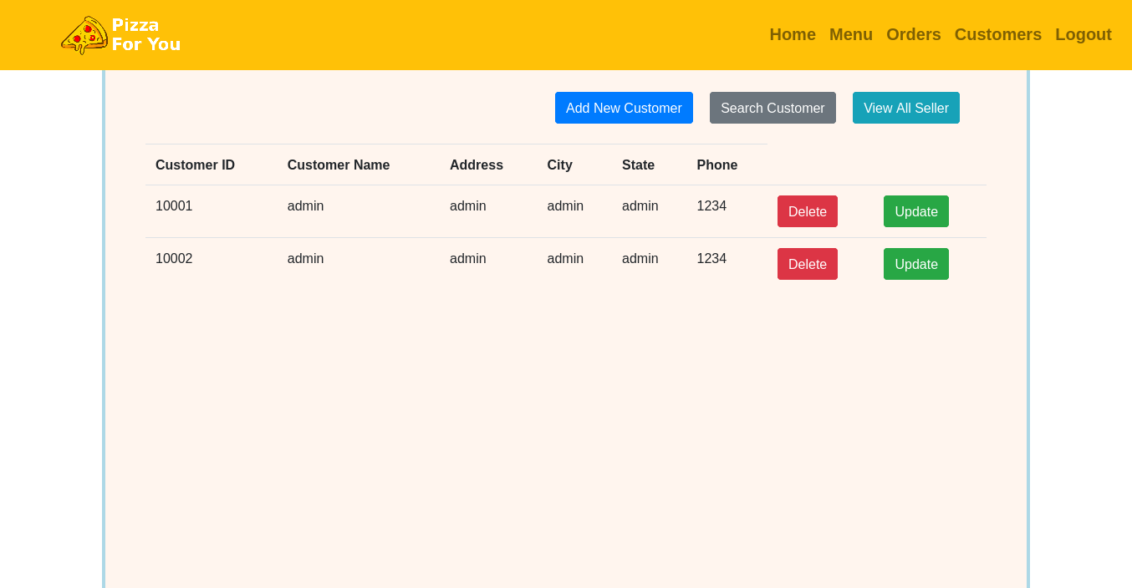

1. You can also search Customers account by clicking the Search Customer button



1. After clicking the button, it will redirected to another page called Customer Search.

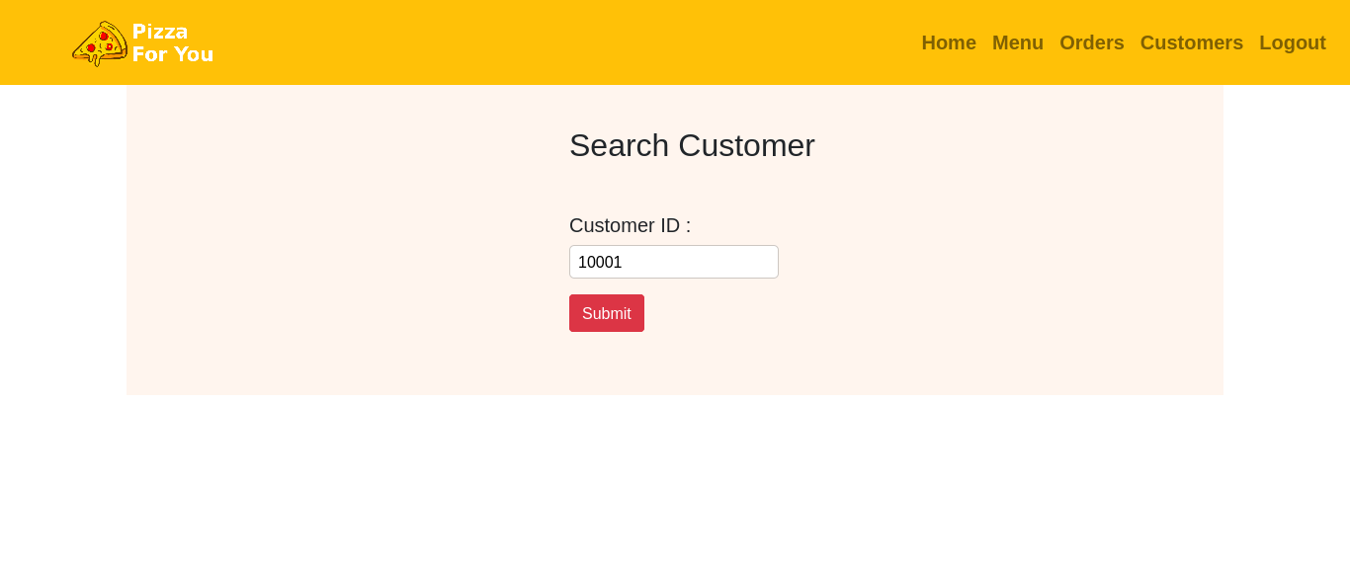

1. Fill the form with the customer ID and click Submit.
2. Then it will redirect to the customers detail page.

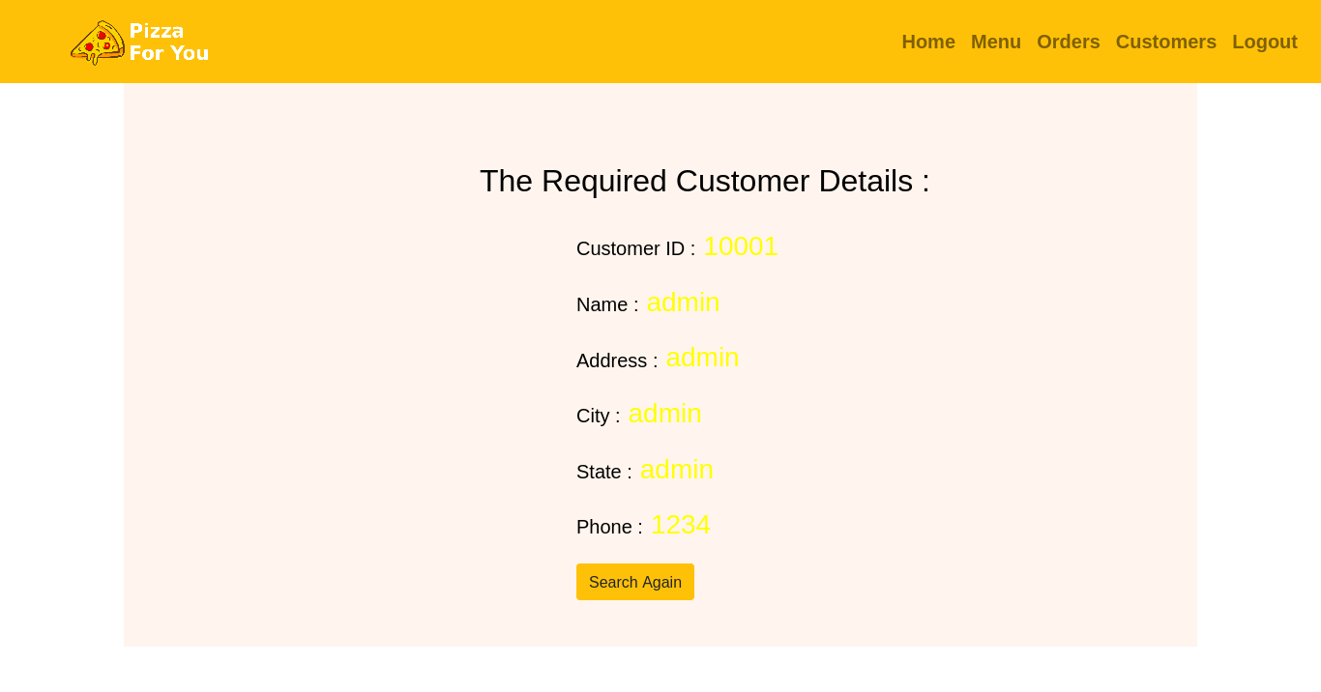**Seller List**

1. Click the View Seller button to view all sellers.
2. It will redirect to Sellers page and this is how it looks like.

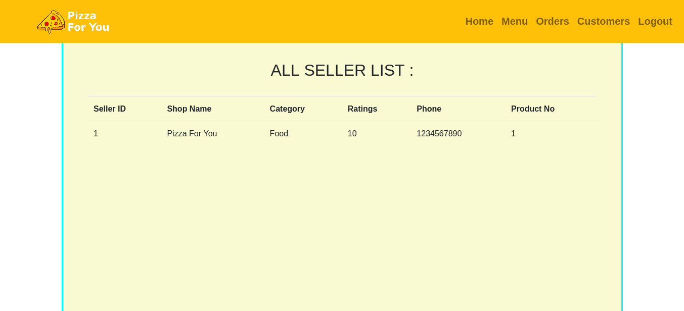

**Setting up Sqlite on Windows**

**Installing Sqlite for Windows**

Step 1. Go to SQLite download page: <https://www.sqlite.org/download.html> and download precompiled binaries from Windows section.

Step 2. Download sqlite-shell-win32-*.zip and sqlite-dll-win32-*.zip zipped files.

Step 3. Create a folder with name C:>sqlite and unzip above two zipped files in this folder, which will give you sqlite3.def, sqlite3.dll and sqlite3.exe files.

Step 4. Add C:>sqlite in your PATH environment variable and finally go to the command prompt and issue sqlite3 command, which should display the following result.

**Setting up Sqlite Browser on Windows**

**Installing Sqlite Browser for Windows**

Step 1. Download and Install SQLITE browser.

* [DB Browser for SQLite - Standard installer for 32-bit Windows](https://download.sqlitebrowser.org/DB.Browser.for.SQLite-3.12.2-win32.msi)

<https://download.sqlitebrowser.org/DB.Browser.for.SQLite-3.12.2-win32.msi>

* [DB Browser for SQLite - Standard installer for 64-bit Windows](https://download.sqlitebrowser.org/DB.Browser.for.SQLite-3.12.2-win64.msi)

<https://download.sqlitebrowser.org/DB.Browser.for.SQLite-3.12.2-win64.msi>

**Creating database using Sqlite Browser**

Step 1. Open your sqlitebrowser and create a new database file.

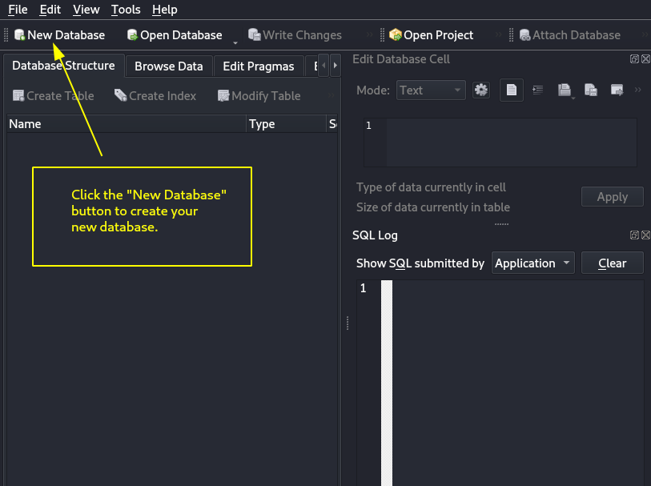

Step 2. Choose filename for you database.

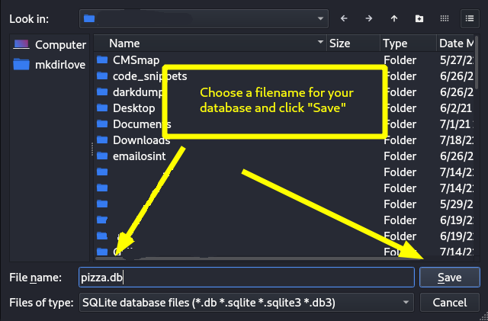

Step 3. Create table and columns.

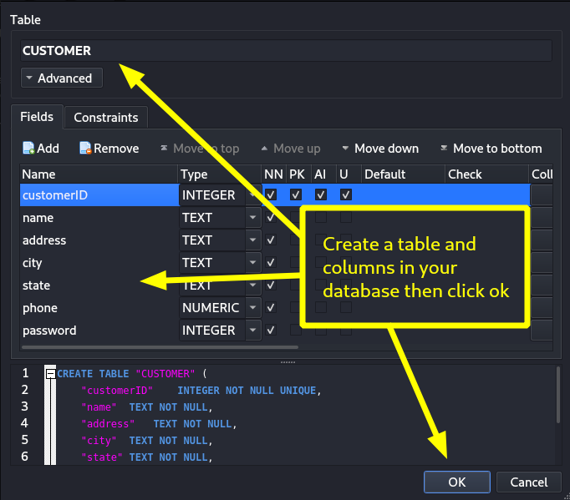

Step 4. Save your database.

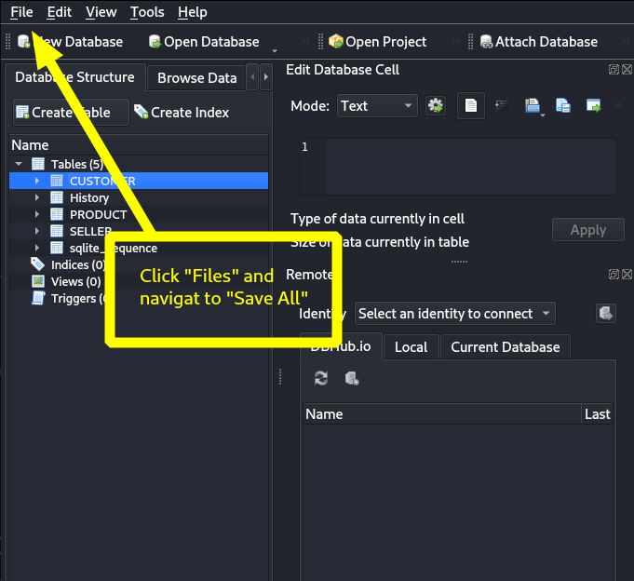

**Connecting Website to Python and Flask Framework**

Step 1. Create a python file named “models.py” and importing the dependencies that are needed then connect your website to your database like the code below.

import sqlite3 as sql

from functools import wraps

from flask import session,flash,redirect,url_for

connect_db ='pizza.db'

Step 2. Create a function that will execute some database commands like the code below. I used the code of our website as a sample.

def customerList():

with sql.connect(connect_db) as db:

qry = 'select * from CUSTOMER'

result = db.execute(qry)

return(result)

Step 3. Create another python file named “server.py” and create a function that will call the function that you created on Step 2. (you can use any filename that you prefer).

# show all Customers

@app.route('/customerList')

def custList():

rows = customerList()

return render_template('customerList.html', rows=rows)

Step 4. Create an HTML file named “customerList.html” that will show the output of the function above if it was rendered on the browser like the example code below.

{% extends "base.html" %}

{% block content %}

<div style="border:4px solid lightblue; background-color: Seashell; height:1500px" class="p-5">

<a href="/newCustomer"><button class="btn btn-primary" style="margin:60px 0 0 490px">Add New Customer</button></a>

<a href="/searchCustomer"><button class="btn btn-secondary ml-3" style="margin-top:60px">Search Customer</button></a>

<a href="/sellerList"><button class="btn btn-info ml-3" style="margin-top:60px">View All Seller</button></a>

<table class="table mt-4" >

<tr>

<th>Customer ID</th>

<th>Customer Name</th>

<th>Address</th>

<th>City</th>

<th>State</th>

<th>Phone</th>

</tr>

{% for row in rows %}

<tr>

<td>{{row[0]}}</td>

<td>{{row[1]}}</td>

<td>{{row[2]}}</td>

<td>{{row[3]}}</td>

<td>{{row[4]}}</td>

<td>{{row[5]}}</td>

<td><a href='/delete/{{row[0]}}'> <button type="button" class="btn btn-danger">Delete</button> </a>

<td><a href='/edit/{{row[0]}}'> <button type="button" class="btn btn-success">Update</button> </a>

</tr>

{% endfor %}

</table>

</div>

{% endblock %}

Step 5. Save all your files the you can run the python file named “server.py” on your command promt or on your IDE then open your browser and navigate to 127.0.0.1:5000 to see the render output.

**THAT’S ALL,**

**THANK YOU!**